Is there anyone who hasn’t heard of Dr. Bassam Shakhashiri
(of “Once Upon a Christmas Cheery in the Lab of Shakhashiri” fame)?!

The Wisconsin Alumni Association - St. Louis Chapter
invites you to
our FIRST Family-friendly…

Founders’ Day 2014
“Bucky Badger and the Joy of Learning”
– A fun event for the entire family!

Tuesday, March 25, 2014
at
Moulin
2017 Chouteau Ave.
St. Louis, MO 63103

Guest Presenter, Bassam Z. Shakhashiri

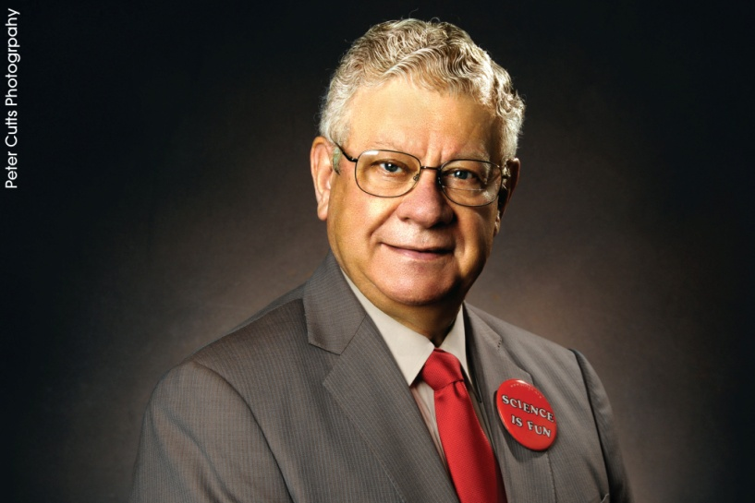

University of Wisconsin – Madison Professor of Chemistry, William T. Evjue Distinguished Chair for the Wisconsin Idea, Director of the Wisconsin Initiative for Science Literacy, and 2012 President, American Chemical Society

Celebrating the beginning of his 45th year as advocate for literacy in science, math, and technology by demonstrating how much fun it can be, Dr. Shakhashiri seeks to impart the joy of discovery, engaging young (and not so young) minds. The master of chemical demonstrations and science policy advocate, Dr. Shakhashiri shares the fun of science through home science activities, public presentations, scholarship, and other programs of the Wisconsin Initiative for Science Literacy. Dr. Shakhashiri will be conducting some of his experiments for us, and showing excerpts from his show featuring a special UW figure!

Badger of the Year, Dr. Jeffrey Parker Henderson,
Assistant Professor of Medicine and Molecular Microbiology
at Washington University School of Medicine
University of Wisconsin – Madison, BS ’94, Chemistry

Come help us honor Dr. Jeffrey Henderson, physician-scientist with training in medicine, infectious diseases, biochemistry, and chemistry, whose research’s goal is discovering new treatment strategies for Gram negative urinary tract infections. Since starting his own laboratory in 2009, he has focused on the role of siderophores in urinary tract infections. His long term goal is to move basic biochemical findings from the laboratory to the bedside.

Reception (appetizer buffet and cash bar) will begin at 6:00 p.m.,
Program from 7:00 – 8:00 p.m.

Cost for reception and program is $39 per person, $15 for kids 11 and under
To register online and pay by credit card, click here.
Registration deadline is Monday, March 17th, 2014.
To register by phone and pay by check, call (888) 947-2586, or email foundersday@uwalumni.com.

We will have a Silent Auction that will be open during the reception. We will give you a sneak preview of the awesome items that will be available at this year’s Founders’ Day Silent Auction before the event, so you can plan your strategy! Most starting bids are 50% of the estimated values. All of the proceeds go to our Gateway Badgers Scholarship Fund.

Cash and check accepted.
For questions contact Sherry Korner at (314) 863-5033 or kre8iv@att.net.

We hope you’ll join us for a great evening!

