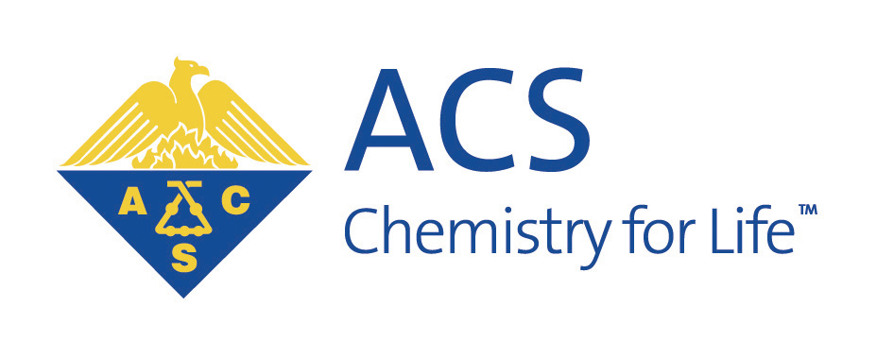
Wisconsin Section
American Chemical Society

Annual Meeting and Banquet
Friday, November 4, 2011

Nadia’s Restaurant
508 State Street

6:00 Wine and Hors d’oeuvres
7:00 Dinner

A short after-dinner program honors
- 2012 ACS Award Winners
- 2011 ACS Fellows
- 50-year ACS members from the Wisconsin Section

Followed by brief remarks by ACS President-Elect
Bassam Shakhashiri

We hope you will join us for the social hour, dinner, and celebration.
For dinner you will be able to choose from a menu of eight entrees.
The Wisconsin Section is partially subsidizing the dinner costs. The price is $50 per person;
$25 for graduate students, $10 for undergraduates.

Please make your check payable to: Wisconsin Section, American Chemical Society and send it to:

Ieva Reich
Department of Chemistry
1101 University Avenue
Madison, WI 53706
ilreich@wisc.edu

Please reserve by Thursday, October 27
Number of reservations is limited

